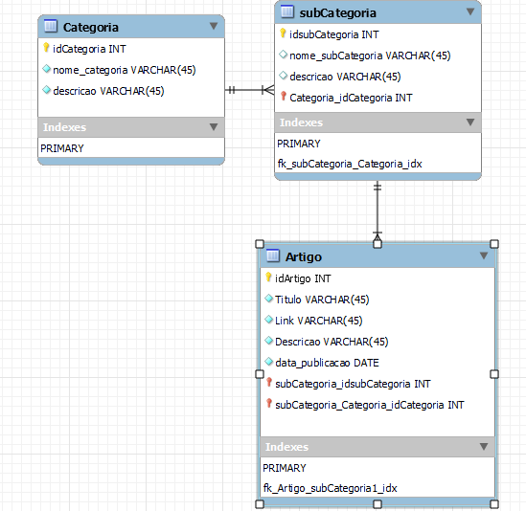

-- MySQL Script generated by MySQL Workbench

-- Wed Feb 21 15:40:09 2024

-- Model: New Model Version: 1.0

-- MySQL Workbench Forward Engineering

SET @OLD_UNIQUE_CHECKS=@@UNIQUE_CHECKS, UNIQUE_CHECKS=0;

SET @OLD_FOREIGN_KEY_CHECKS=@@FOREIGN_KEY_CHECKS, FOREIGN_KEY_CHECKS=0;

SET @OLD_SQL_MODE=@@SQL_MODE, SQL_MODE='ONLY_FULL_GROUP_BY,STRICT_TRANS_TABLES,NO_ZERO_IN_DATE,NO_ZERO_DATE,ERROR_FOR_DIVISION_BY_ZERO,NO_ENGINE_SUBSTITUTION';

-- -----------------------------------------------------

-- Schema base_conhecimento

-- -----------------------------------------------------

-- -----------------------------------------------------

-- Schema base_conhecimento

-- -----------------------------------------------------

CREATE SCHEMA IF NOT EXISTS `base_conhecimento` DEFAULT CHARACTER SET utf8 ;

USE `base_conhecimento` ;

-- -----------------------------------------------------

-- Table `base_conhecimento`.`Categoria`

-- -----------------------------------------------------

CREATE TABLE IF NOT EXISTS `base_conhecimento`.`Categoria` (

`idCategoria` INT UNSIGNED NOT NULL AUTO_INCREMENT,

`nome_categoria` VARCHAR(45) NOT NULL,

`descricao` VARCHAR(45) NOT NULL,

PRIMARY KEY (`idCategoria`))

ENGINE = InnoDB;

-- -----------------------------------------------------

-- Table `base_conhecimento`.`subCategoria`

-- -----------------------------------------------------

CREATE TABLE IF NOT EXISTS `base_conhecimento`.`subCategoria` (

`idsubCategoria` INT UNSIGNED NOT NULL AUTO_INCREMENT,

`nome_subCategoria` VARCHAR(45) NULL,

`descricao` VARCHAR(45) NULL,

`Categoria_idCategoria` INT UNSIGNED NOT NULL,

PRIMARY KEY (`idsubCategoria`, `Categoria_idCategoria`),

INDEX `fk_subCategoria_Categoria_idx` (`Categoria_idCategoria` ASC) VISIBLE,

CONSTRAINT `fk_subCategoria_Categoria`

FOREIGN KEY (`Categoria_idCategoria`)

REFERENCES `base_conhecimento`.`Categoria` (`idCategoria`)

ON DELETE NO ACTION

ON UPDATE NO ACTION)

ENGINE = InnoDB;

-- -----------------------------------------------------

-- Table `base_conhecimento`.`Artigo`

-- -----------------------------------------------------

CREATE TABLE IF NOT EXISTS `base_conhecimento`.`Artigo` (

`idArtigo` INT UNSIGNED NOT NULL AUTO_INCREMENT,

`Titulo` VARCHAR(45) NOT NULL,

`Link` VARCHAR(45) NOT NULL,

`Descricao` VARCHAR(45) NOT NULL,

`data_publicacao` DATE NOT NULL,

`subCategoria_idsubCategoria` INT UNSIGNED NOT NULL,

`subCategoria_Categoria_idCategoria` INT UNSIGNED NOT NULL,

PRIMARY KEY (`idArtigo`, `subCategoria_idsubCategoria`, `subCategoria_Categoria_idCategoria`),

INDEX `fk_Artigo_subCategoria1_idx` (`subCategoria_idsubCategoria` ASC, `subCategoria_Categoria_idCategoria` ASC) VISIBLE,

CONSTRAINT `fk_Artigo_subCategoria1`

FOREIGN KEY (`subCategoria_idsubCategoria` , `subCategoria_Categoria_idCategoria`)

REFERENCES `base_conhecimento`.`subCategoria` (`idsubCategoria` , `Categoria_idCategoria`)

ON DELETE NO ACTION

ON UPDATE NO ACTION)

ENGINE = InnoDB;

SET SQL_MODE=@OLD_SQL_MODE;

SET FOREIGN_KEY_CHECKS=@OLD_FOREIGN_KEY_CHECKS;

SET UNIQUE_CHECKS=@OLD_UNIQUE_CHECKS;